Project 2 • Unit 5
1 Look at the picture and write questions for the answers.
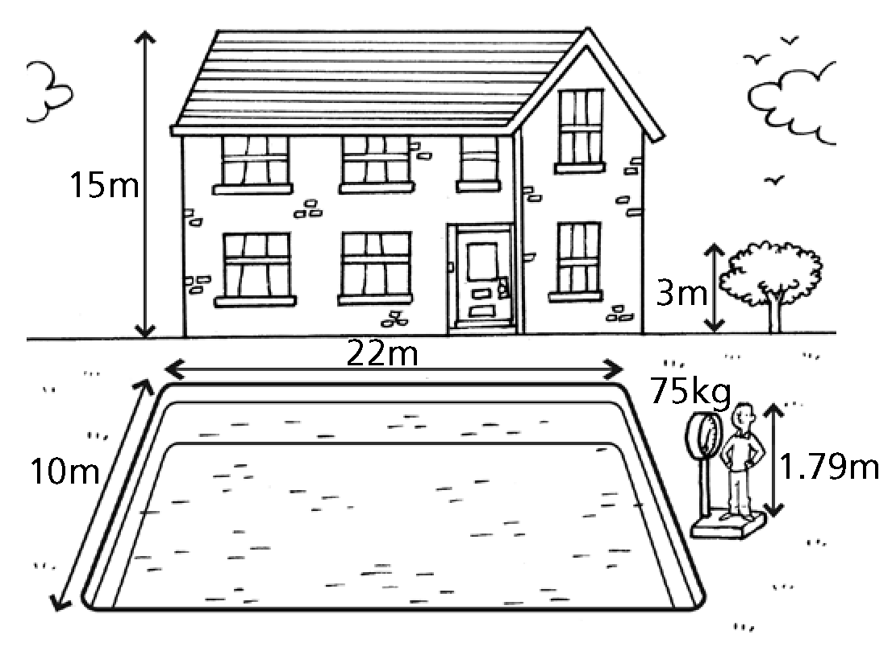

Example
15 m How high is the house?
1 3 m
2 75 kg
3 22 m
4 10 m
5 1.79 m

2 Complete the sentences with the correct form of the adjectives.
Example
Food in the supermarket is cheap, but it is cheaper in the market.
1 Her mum is a good cook, but my mum is __________.
2 I got a bad mark for Maths, but Laura’s mark was __________.
3 How tall am I? Well, I am __________ than my dad.
4 This computer is expensive, but that computer is __________.
5 Our dog is old, but Jo’s is even __________.
6 The weather is sunny in June, but it is __________ in July.
7 It’s hot today, but it was __________ yesterday.
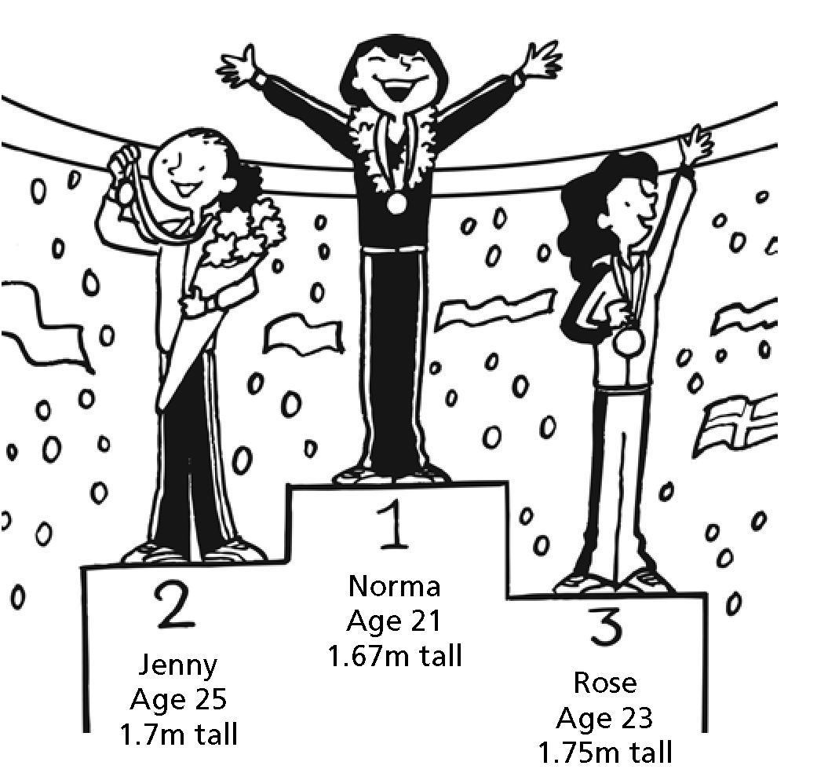

3 Write sentences comparing the athletes. Use the correct form of the adjectives.
Examples
Jenny / Norma / old
Jenny is older than Norma.
All three / young
Jenny is the youngest.
1 Norma / Jenny / short

2 Norma / Rose / good

3 Rose / Jenny / tall

4 Norma / Rose / young

5 All three / good

6 Jenny / Norma / bad

7 All three / tall

8 All three / old

4 Label the picture.
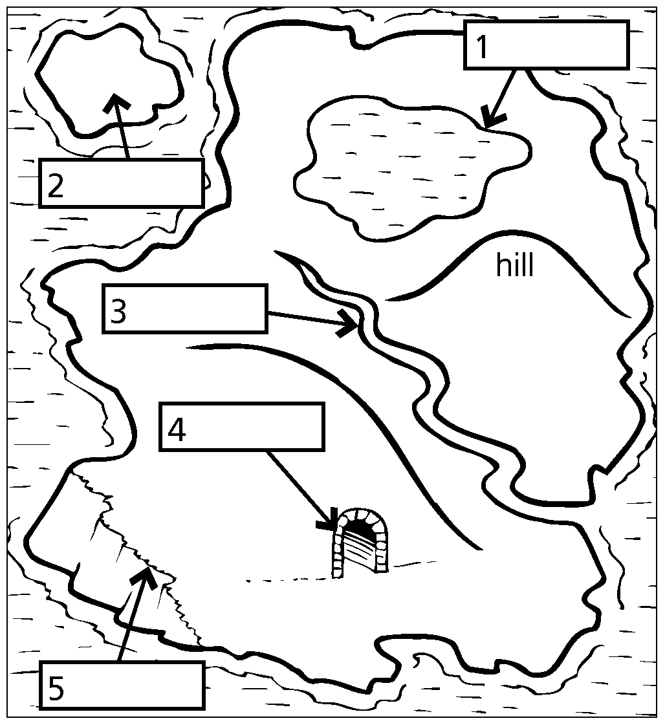

5 Write the opposite of the adjectives.
1 heavy
2 easy
3 hot
4 wet
5 cheap

6 Read about Fantasyland and correct the mistakes in the sentences.
Fantasyland is a place where only magical creatures live. It is an island bigger than Cyprus, but smaller than Ireland.
Ireland and Fantasyland are very wet. Cyprus is a very dry island. But Fantasyland is hotter than Ireland. Because the grass grows better in hot, wet climates, Fantasyland is the greenest island.
Irish and Cypriot people are normal size, but the Fantasylanders are very small. The tallest Fantasylander is no more than one metre high.
None of the animals you find in the real world exist in Fantasyland. For example, there are no cats and dogs, but a strange animal called a dat, which has the head of a dog, the body of a cat and no tail. There are over a hundred species of animal on the island.
There is one more difference between Fantasyland and the other two islands. You can visit Ireland and Cyprus by plane, but you can only visit Fantasyland when you play the computer game Magic Islands.

Example
Fantasyland is the biggest island.
Ireland is the biggest island.
1 Cyprus is wetter than Fantasyland.

2 The grass is greener in Ireland than in Fantasyland.

3 Ireland is hotter than Fantasyland.

4 The tallest people live in Fantasyland.

5 Some Fantasylanders are over one metre tall.

6 A dat has a cat’s body and dog’s tail.

7 There are more than a hundred kinds of animal in Ireland.

8 There are some real people on Fantasyland.

9 You can’t go to Cyprus by plane.

10 Fantasyland is the name of a computer game.

